Coding Genetic Algorithm using MATLAB

By Akansh Maurya (Institute of Engineering and Technology, Lucknow)

# Abstract

In computer science and operations research, a genetic algorithm (GA) is a meta-heuristic inspired by the process of natural selection that belongs to the larger class of evolutionary algorithms (EA). Genetic algorithms are commonly used to generate high-quality solutions to optimization and search problems by relying on bio-inspired operators such as mutation, crossover and selection. John Holland introduced genetic algorithms in 1960 based on the concept of Darwin’s theory of evolution; afterwards, his student David E. Goldberg extended GA in 1989.

GA Operators and Parameters

* Selection
* Crossover
* Mutation
* Elitism

**Selection:**

A fitness function value quantifies the optimality of a solution. The value is used to rank a particular solution against all the other solutions. A fitness value is assigned to each solution depending on how close it is actually to the optimal solution of the problem.

**Crossover:**

The crossover operator is used to create new solutions from the existing solutions available in the mating pool after applying selection operator. This operator exchanges the gene information between the solutions in the mating pool. The most popular crossover selects any two solutions strings randomly from the mating pool and some portion of the strings is exchanged between the strings.

**Mutation:**

Mutation is the occasional introduction of new features into the solution strings of the population pool to maintain diversity in the population. Though crossover has the main responsibility to search for the optimal solution, mutation is also used for this purpose. Mutation operator changes a 1 to 0 or vice versa, with a mutation probability of 0.1 or near. The mutation probability is generally kept low for steady convergence. A high value of mutation probability would search here and there like a random search technique.

**Elitism:**

Elitism is the preservation of few best solution of the population pool.

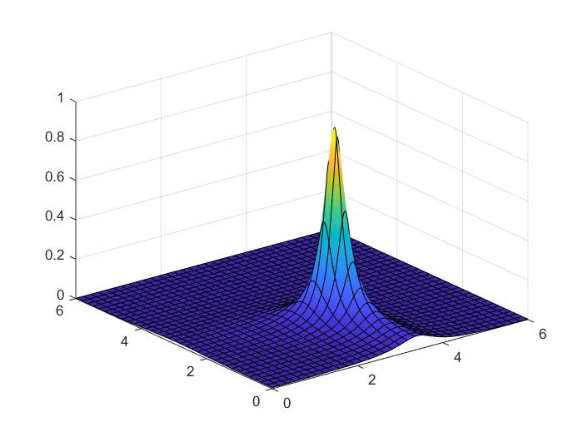

**Problem Statement:** A question from Deb Kalyanmoy - Optimization for Engineering Design_ Algorithms and Examples-PHI Learning (2012)

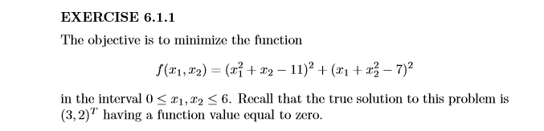

**Solution:**

Problem Definition:

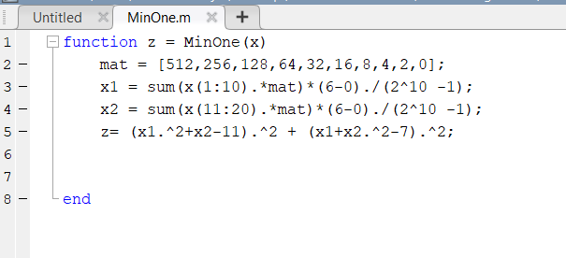

Selection is done in main Script.

Crossover:

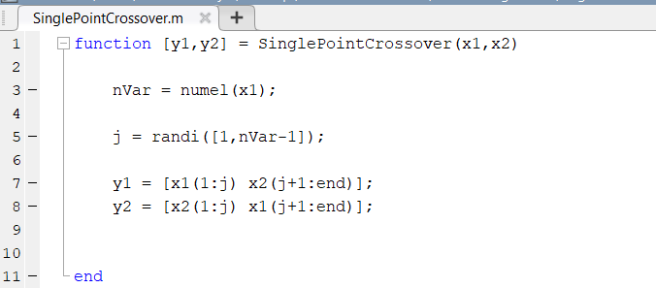

Mutation:

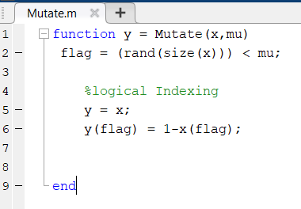

Elitism:

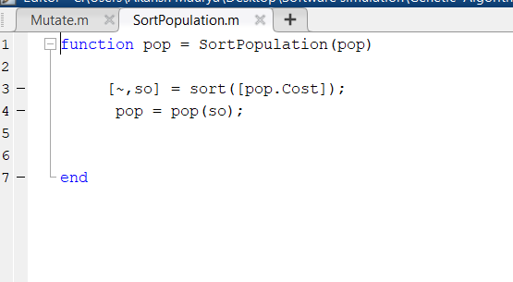

**Result:**

No. of genes: **10**

No. of iteration: **100**

Crossover Probability: **0.8**

Mutation Probability: **0.1**

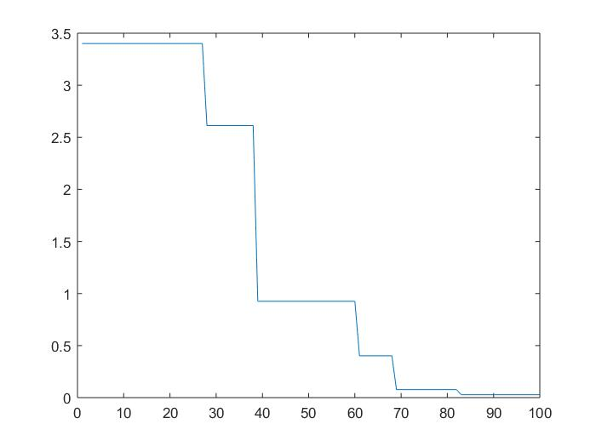

**X- Axis: No. of Iteration**

**Y- Axis: Cost of Function**

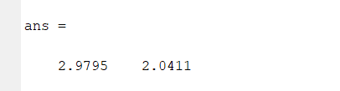X1 and X2 respectively shown below: